Theatre Booking System

Taras svynarchuk
2026
Contents
Investigation 2
Desk based research 3
Stakeholders 3
Limitations of current system 3
Aims and Objectives 3
Design 3
Sub programs 4
Task List 4
Algorithms 4
User Interface 4
UML 4
Data Dictionary 4
Software Development 5
Developmental Testing 6
Testing 6
Evaluation 7

Investigation

Desk based research
Use this to look online for similar solutions, you should print screen your findings identifying any features you like and will be trying to incorporate into your solution as well as features you think don’t work.
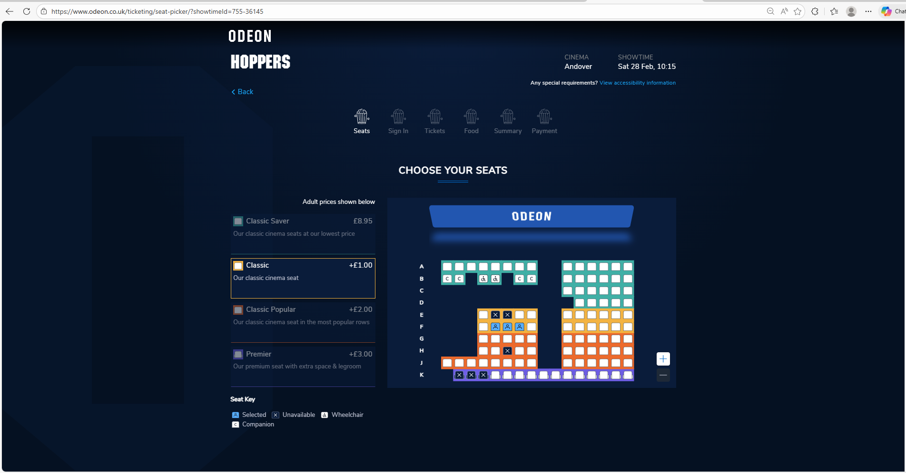
I like the dark theme used here and also the selected seats being displayed with a small person icon however I don’t like the bland looking seats so I will try to implement the dark theme into my system and also the seating layout is diverse so I will try to create an exotic layout as well.

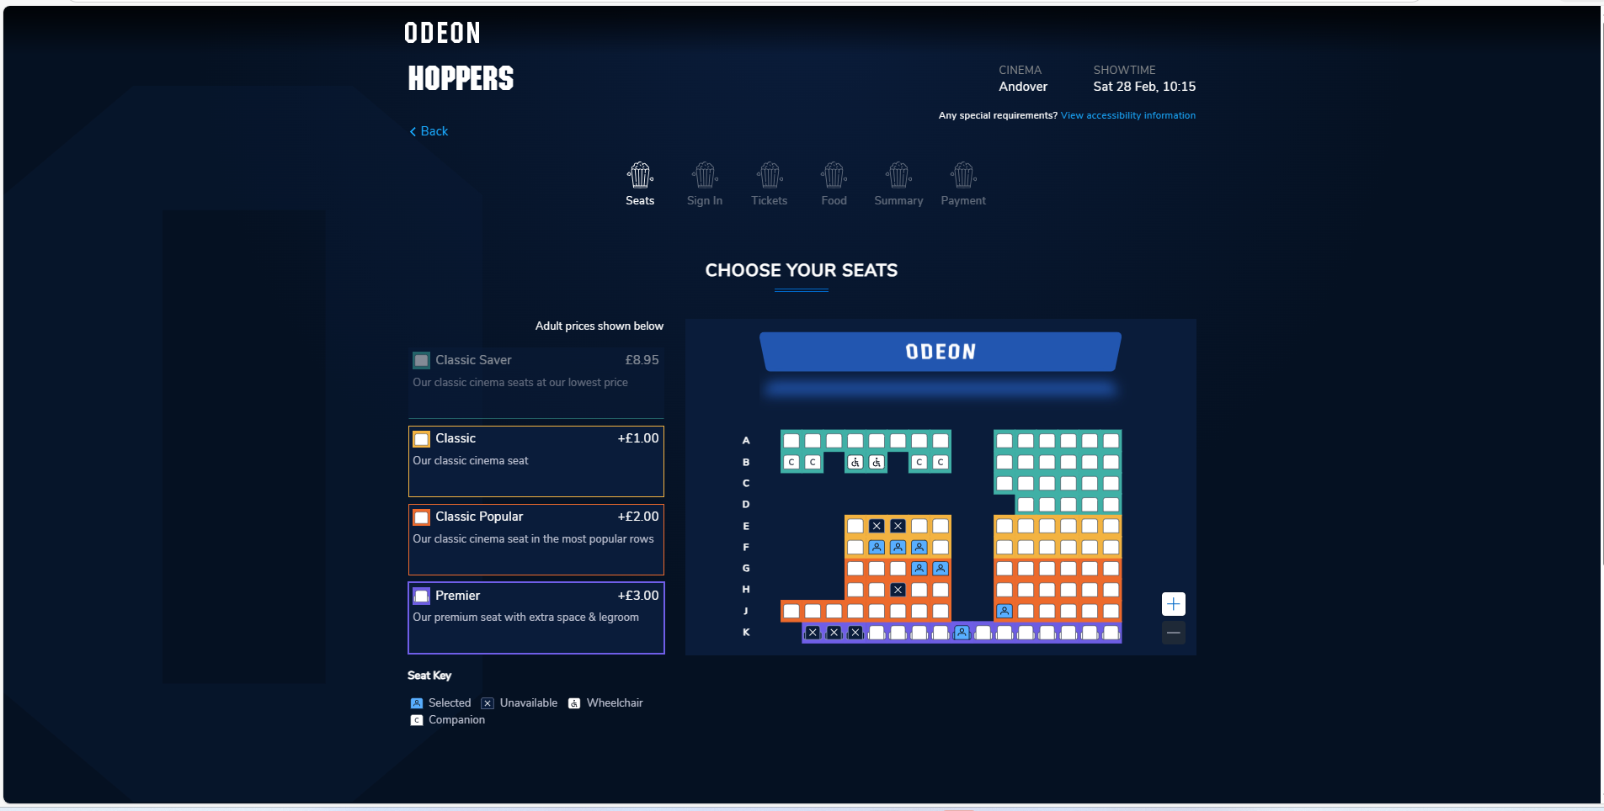
Also the ability to select the seat pricing is cool with the seat types being colour coded for easy of use
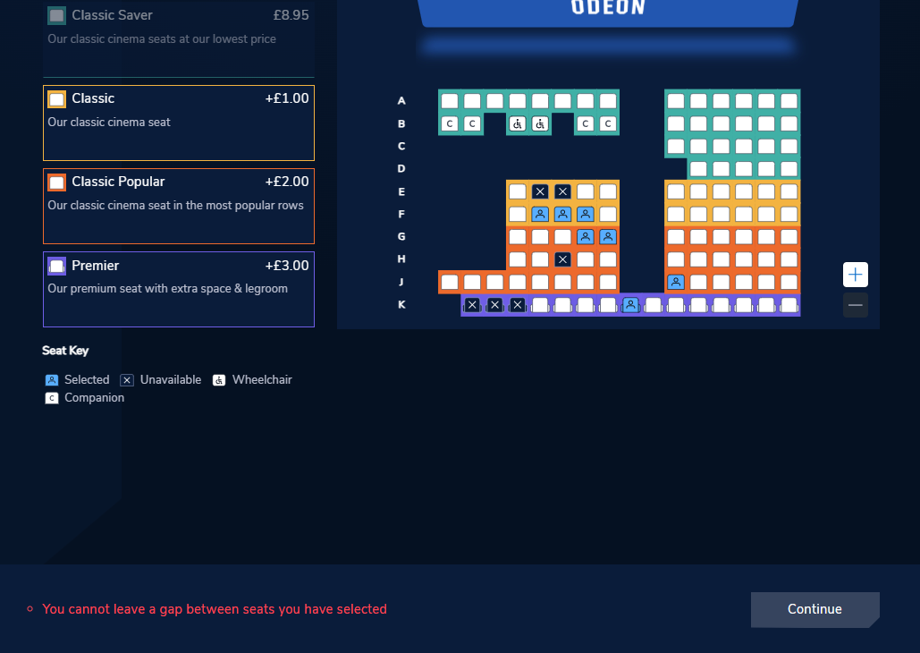 the website has also implemented a feature that says you cannot leave a gap between the seats since I have left 1 seat spare on row F
-------------------------------------------------------------------------------------------------------------------------------
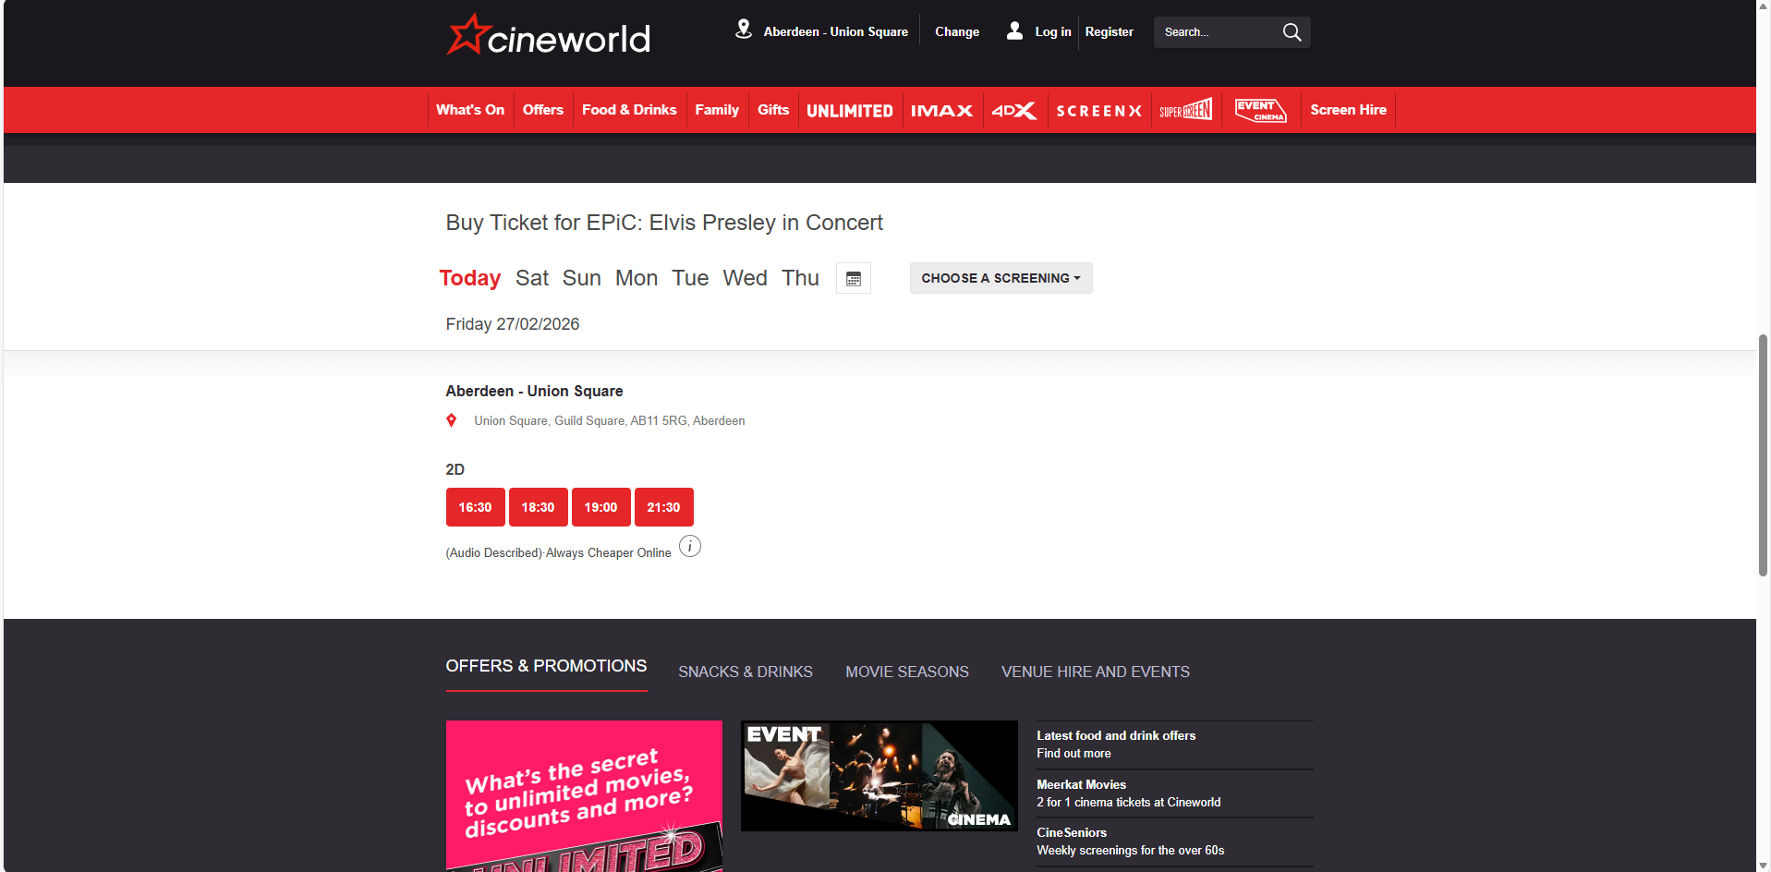this cinema website has included a time selection and a date selection menu before reaching the seat selection page which is a good feature but I don’t think ill do this since the performances at the college will always take place at the same time but I will need to allow the user to select the date since the performances happen on different days
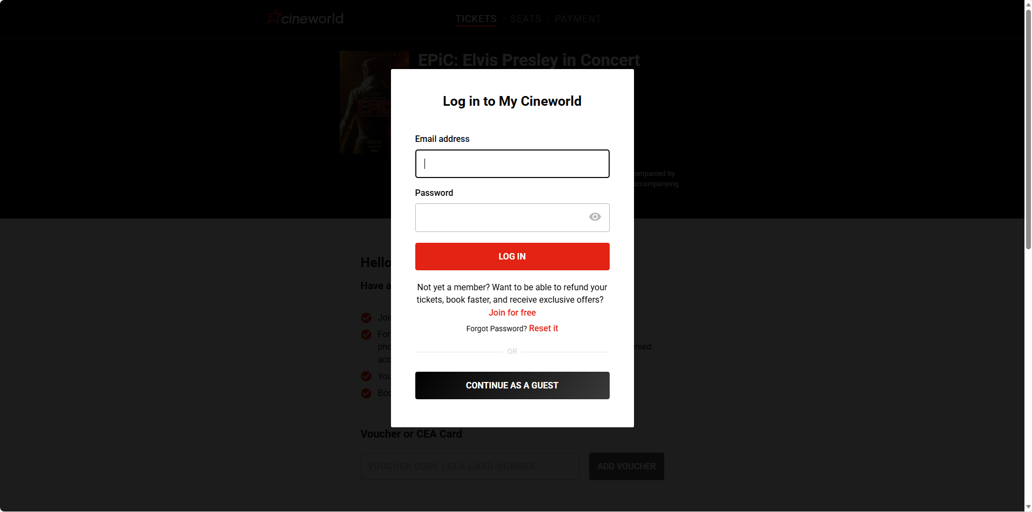the website then prompts you to login or continue as a guest which I might implement as logging in will allow me to generate the online ticket seamlessly but allowing the user to continue as a guest will be a good user interface solution.
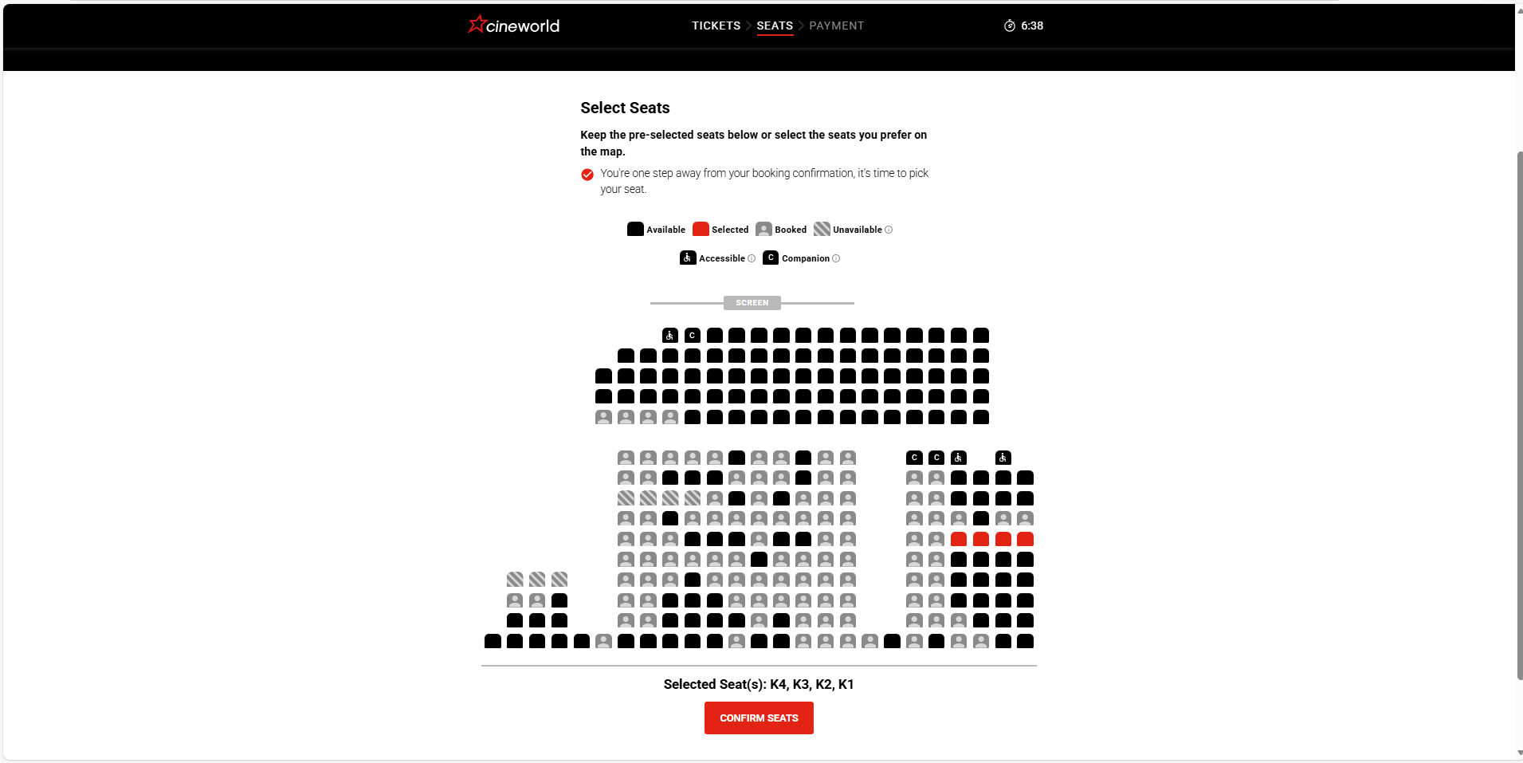here they used simple black squares to represent a free seat and a default user icon to represent a taken seat which seems boring but simple and intuitive. I think I will use colour coded seats and include a key to allow the user to determine what colour seat means what.
------------------------------------------------------------------------------------------------------------------------------------

Stakeholders
What are the stakeholders and what are their requirements for the solution, these should be as diverse as possible and will have different requirements.

Limitations of current system
The current system is paper based with the performing arts teachers taking notes about any tickets sold.

Aims and Objectives

Design

Sub programs

Break your objectives into subprograms, for example.
10. Since the club sells items such as golf clubs and golf balls, they will need a way to add these sale values to the database.
10.1. It will need a feature to search through all the items to get the details of the item you want.
10.2. There needs to be a way to allow for both selling and lending items.
10.3. They must only be able to add the number of items in stock and can’t go over that stock.
10.4. Also, the prices should automatically be worked out by the program when they are added to the cart.
10.5. An option to select quantity before adding to cart should be available to save time pressing add multiple times.
10.6. You should also be able to remove items from the cart.
10.7. Once all the items the user wants to add are added to the item cart there then should be an option to add it to the overall main cart that contains all the things the user has purchased.

Task List
For each task (sub program) you need to identify the inputs, outputs and processing
Task | Input | Output | Processing

Algorithms
Each subtask should have its own algorithm written in pseudocode, these should be clear enough for a third party (fellow students) to follow, consider if someone in the class could make your system from these designs.
These should be lots of separate algorithms, I don’t need to see any algorithms for the user interface as these are designed above.

User Interface
Draw annotated designs of your user interface. These should be detailed enough that another person could make your system and it will look as you envision.

UML
Include all your UML here, this could be an ERD, DFD or class diagram

Data Dictionary
Fill in the table for each of your entities.
Attribute/Field | Data type | Validation | Key | Comments

Developmental Testing

Identify at least 5 different problems you had and your solutions, there should be before and after images.

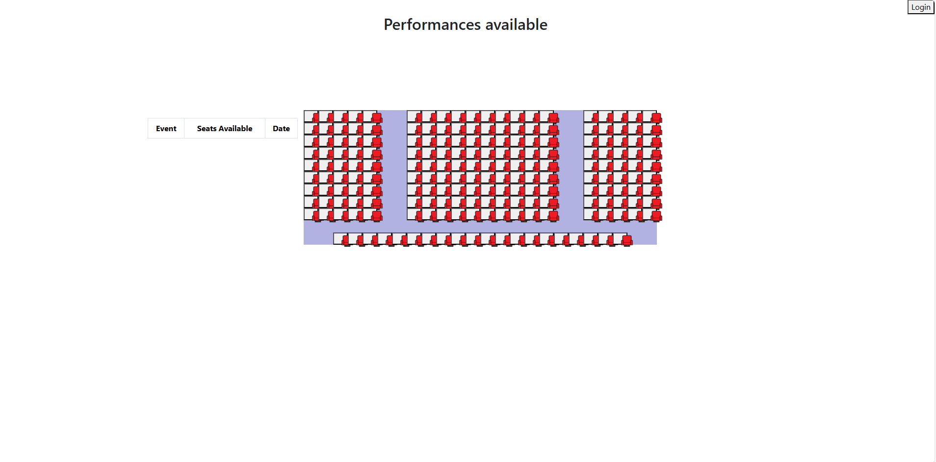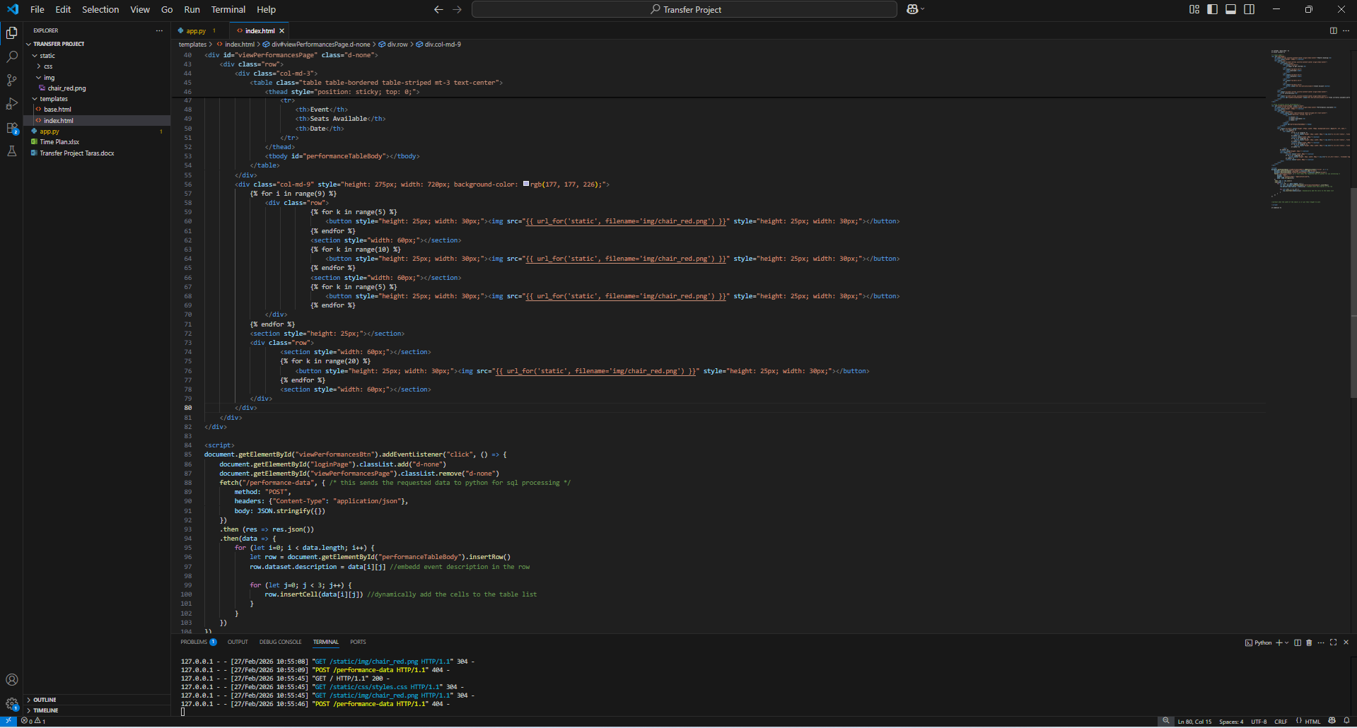

Im trying to design the button layout for the theatre and the seat icons aren’t aligning directly on the buttons which are layed out as intended. I think I will crop the images very precisely on the left hand side so that when they are placed in the button from the left it begins with the actual visible part of the icon.
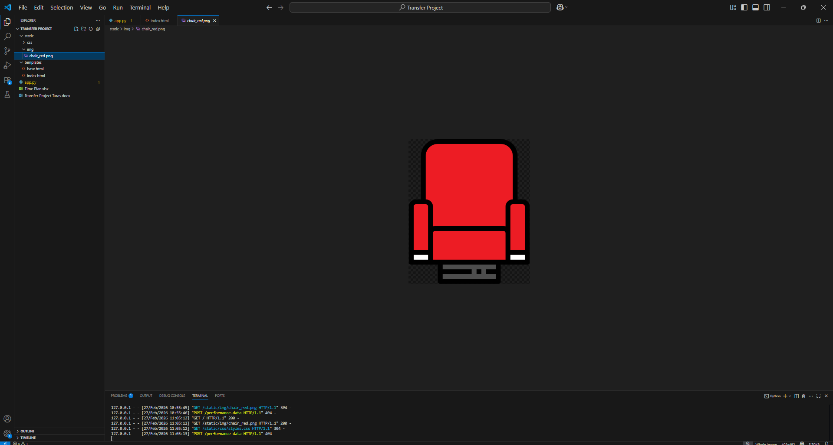

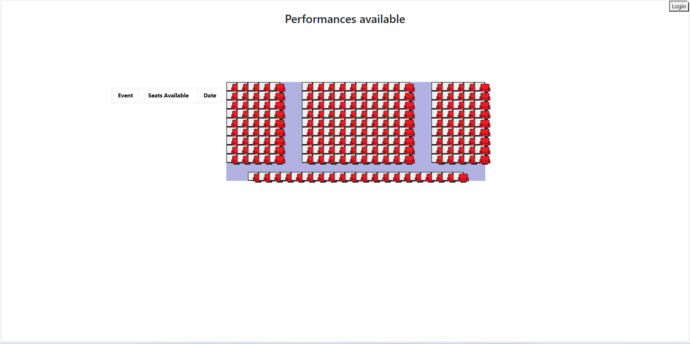
I cropped the image very tightly but that didn’t help so I will try to align the image to the left and see if that helps
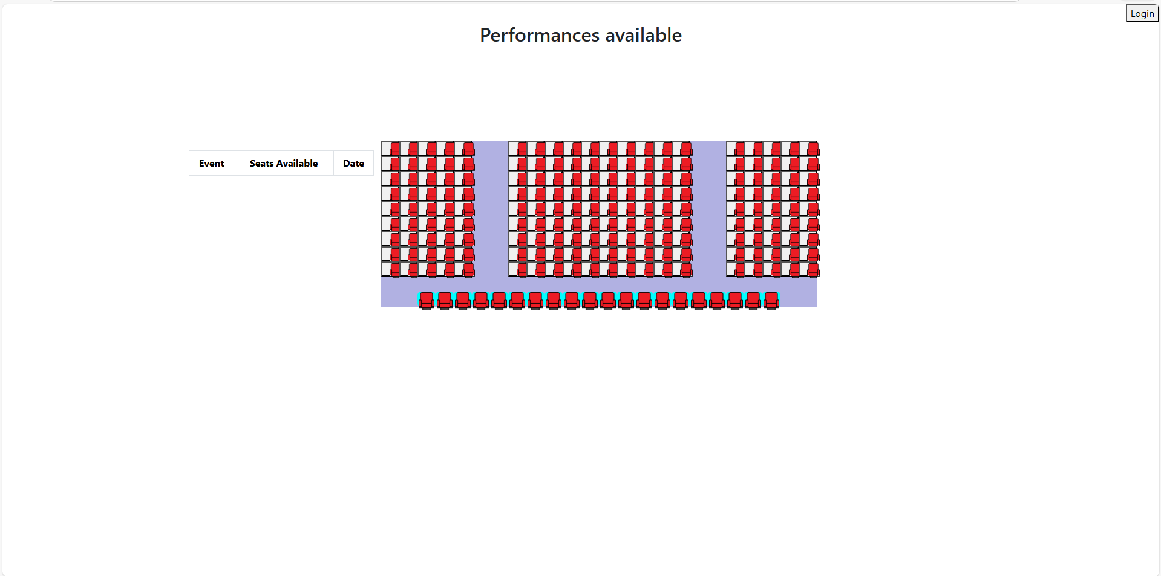
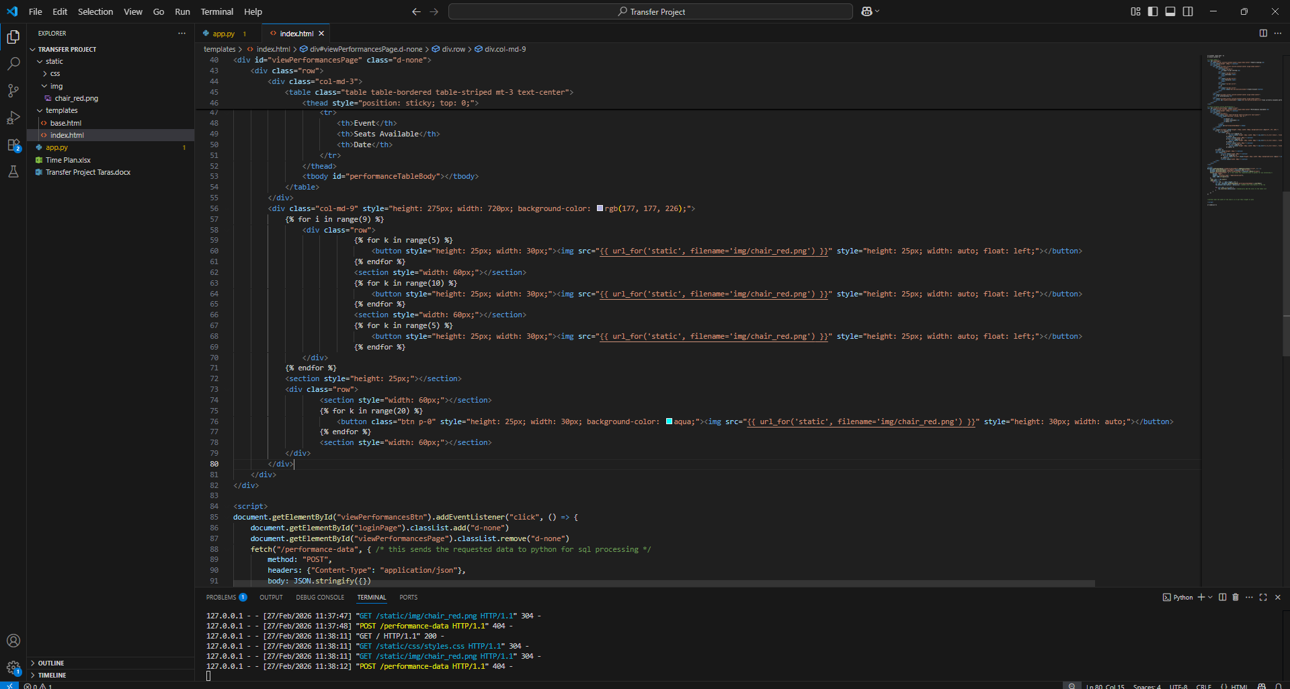
I managed to get the bottom row to work as imtented with the seats aligning in the center, now I will remove all the colouring and apply the same padding-0 to the rest of the buttons

Testing
Complete the testing table, you must comprehensively test your solution using a range of testing criteria. Testing should include:
- Valid data – data with expected outcomes that should be accepted by any validation you have included
- Invalid data – data that should be rejected with an error message
- Erroneous data – symbols etc in text fields that could break everything
- Extreme data – only used for range checks, data that should be accepted but is on the edges of acceptable.
Test | Test type | Test data | Expected result | Actual result | Commentary

Evaluation
You should write a detailed evaluation covering the following points
- How effective the language including libraries etc you chose is for solving this and what features you used.
- Compared the system you have made with those you researched for your desk based research.
- Identified strengths and weaknesses of your system with potential improvements, you don’t have to program these so you can be imaginative
- Your own strengths and weaknesses, consider each stage of the process
- Identify any personal changes you would make for the future

